**EXPERIMENT:9**

**VIEWS:**

CREATE TABLE table1 (num_value int, name varchar(20), occupation varchar(20), age varchar(20));

desc table1;

INSERT INTO table1 values (101, 'Peter', 'Engineer', 32);

INSERT INTO table1 values(102, 'Joseph', 'Developer', 30);

INSERT INTO table1 values(103, 'John', 'Leader', 28);

INSERT INTO table1 values(104, 'Stephen', 'Scientist', 45);

INSERT INTO table1 values (105, 'Suzi', 'Carpenter', 26);

INSERT INTO table1 values (106, 'Bob', 'Actor', 25);

select * from table1;

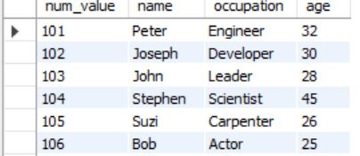

CREATE VIEW customer AS

SELECT num_value, occupation

FROM table1;

select * from customer;

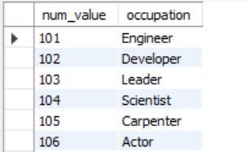

Show create view customer;



drop view customer;

